Problem Chosen  A | 2026 XATU MCM/ICM  Summary Sheet | Team Control Number  2026024

Use this template to begin typing the first page (summary page) of your electronic report. This template uses a 12-point Times New Roman font. Submit your paper as an Adobe PDF electronic file (e.g. 1111111.pdf), typed in English, with a readable font of at least 12-point type.

Do not include the name of your college, advisor, or team members on this or any page.

Papers must be within the 25 page limit.

Be sure to change the control number and problem choice above.
You may delete these instructions as you begin to type your report here.

Content
Content 2
1. Introduction 3
1.1 Background 3
1.2 Work 3
2. Problem analysis 3
2.1 Data analysis 3
2.2 Analysis of question one 3
2.3 Analysis of question two 3
2.4 3
2.5 3
3. Symbol and Assumptions 3
3. 1 Symbol Description 3
3.2 Fundamental assumptions 4
4. Model 4
5.Test the Models 4
6. Sensitivity Analysis 4
7.Strengths and Weakness 4
8.Conclusion 4
References 4
Appendix 4

- Introduction
  - Background
In public safety emergencies such as fires or gas leaks, efficient emergency evacuation is critical for saving lives. The "sweep" operations executed by trained responders, which aim to guarantee no one is left behind, are a critical part of the evacuation process. The efficiency and strategy behind these sweeps can directly determine the success or failure of the rescue.
However, this task faces severe challenges. Real-world buildings vary in layout, number of floors, and location of exits. Responders must make decisions under immense pressure to act quickly, often with limited information. Traditional, experience-based sweep methods are prone to redundant search paths, inefficient resource allocation, and time delays, placing both responders and any remaining occupants in true peril. Therefore, designing rational sweep paths for them is critically important.
This year, our team has been asked by the Clearing Of Multi-use Assembly Public/Private spaces (XATU) to design a mathematical model to optimize sweeping strategies in multi-floor buildings during emergency evacuations. We will maximize the collaborative efficiency of the responder team—while strictly prioritizing occupant safety —to ensure all rooms are cleared in the shortest possible time. This study incorporates building complexity, information uncertainty, and dynamic risks into a unified framework. It is dedicated to transforming the sweep task into a quantifiable and optimizable systematic problem, providing decision support for scientific rescue.

  - Problem Restatement
The challenge is to design a mathematical model to optimize sweeping strategies during fires or other emergencies in buildings that vary in layout. The goal is to ensure all rooms are cleared in the shortest possible time , while prioritizing occupant safety and responder efficiency.
Problem 1: For a one-story office building with three similar-sized rooms on each side of a central hallway, where rooms are only connected to the hallway , determine a model for how two fire fighters can sweep the building efficiently and find the minimum time to complete this sweep.
Problem 2: For at least two additional building layouts with a varying number of responders , which must include changes to the number of floors, the floor plan, and the occupants of the rooms , use the model to determine:
- The optimal number of responders and their starting positions.
- The paths used during the sweep (order of rooms to be checked).
- The minimum time to fully sweep the building.
Problem 3: Extend the model to incorporate more realistic constraints in non-standard building layouts. This includes factors such as decreased visibility , people moving dynamically during evacuation , and the prioritization of high-risk areas. Determine how to assign responders and plan an evacuation sweep strategy to ensure maximum safety in the shortest possible time.
  - Our Work
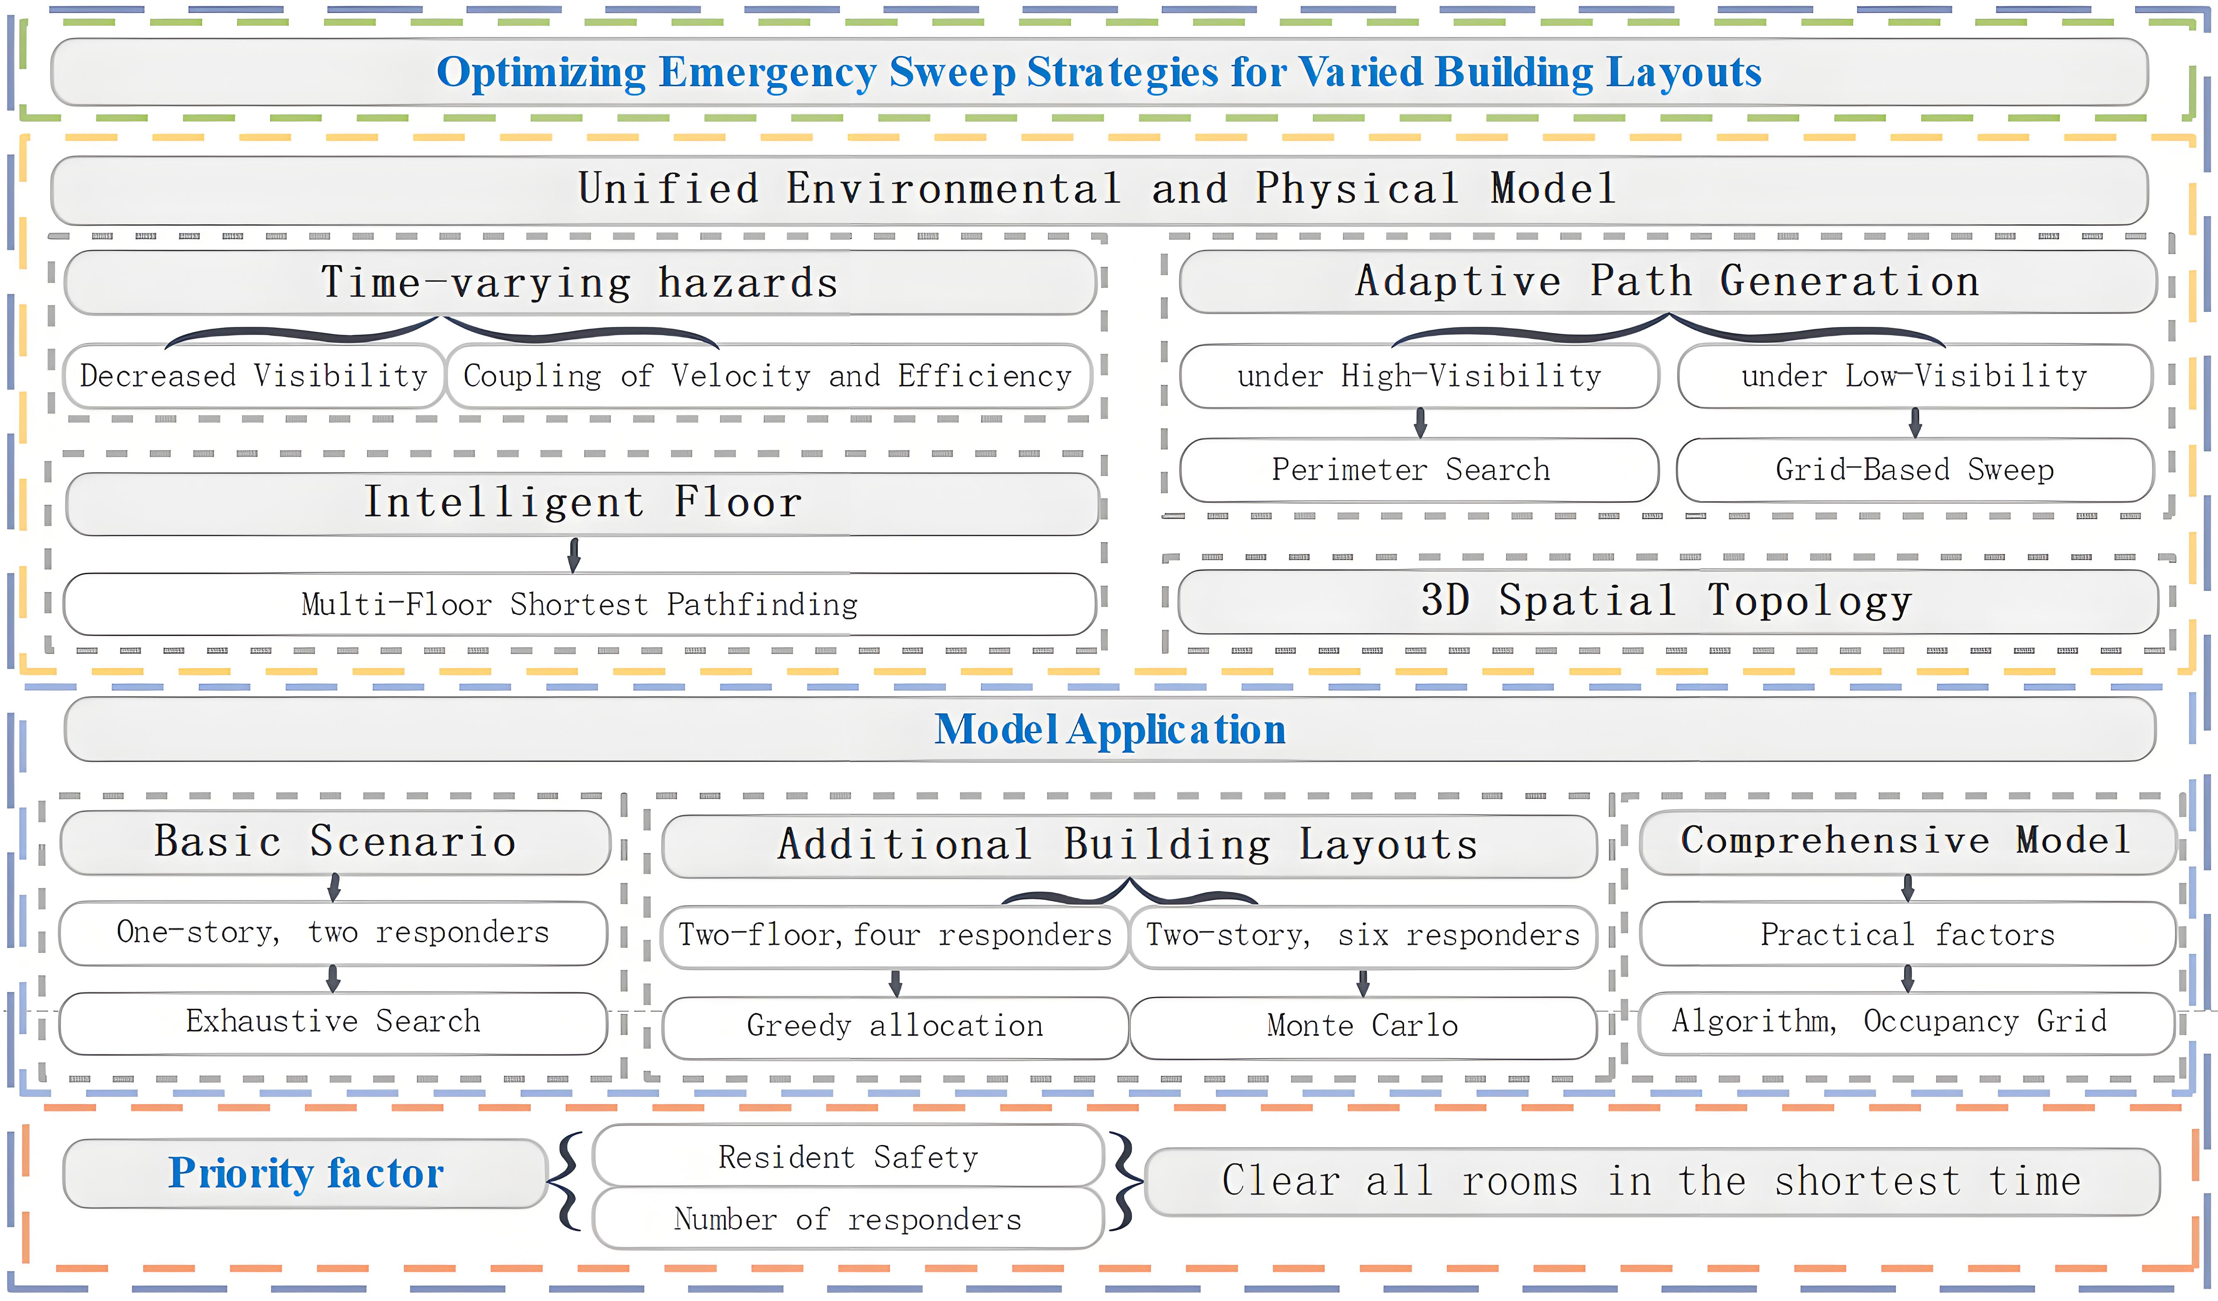
Figure 1-1 Our Work
  - Problem Analysis
This study aims to construct an optimized sweep model to maximize occupant safety and responder efficiency, and to clear all rooms in the shortest possible time. The criterion for a room being "all-clear" is that a responder has successfully swept it. The minimum time is defined as when all responders have completed sweeping their assigned rooms and have evacuated via an exit.
The problem is decomposed into three progressive levels:
(1) Problem 1: Baseline Model A one-story building with six rooms and two responders. This scenario is used to validate a zoning strategy and the effectiveness of a "full-space search" baseline algorithm in an ideal environment.
(2) Problem 2: Multiple Layouts and Scalability Introduce multi-floor layouts (e.g., two floors, six rooms; two floors, multi-rooms) and a varying number of responders to address 3D spatial topology and complex task assignment problems.
- Two-floor, six-room: Employ "brute-force full permutation" and "greedy assignment."
- Two-floor, multi-room: To handle the "combinatorial explosion," use "Monte Carlo sampling" and "greedy load balancing" to find a near-optimal solution.
(3) Problem 3: High-Fidelity Dynamics and Special Scenarios In a realistic, non-standard building layout, the environment is high-dimensional and time-varying. New variables are introduced, such as "occupant locating," "prioritization of high-risk areas," "dynamic movement," and "redundancy rules." A hybrid strategy is adopted. At the "micro-grid level," A* and Dijkstra algorithms are used for path planning. At the "macro-level," a "greedy complex decision-making" process is used to assign prioritized tasks.

- Assumptions and Rationale
Given that real-world problems often involve numerous complex factors, we must first establish reasonable assumptions to simplify the model:
- Indoor-Outdoor Environment Isolation Assumption In the context of this study, the effect of wind on smoke is assumed to be negligible. The indoor and outdoor environments are considered relatively isolated, meaning indoor smoke diffusion is not correlated with outdoor wind factors.
- Responder Sweep Method Assumption Responders are assumed to rely solely on visual inspection when executing sweep tasks, without the aid of other auxiliary detection equipment or methods.
- Uniform Smoke Onset Assumption All rooms are assumed to start producing smoke synchronously and uniformly at the same time. The onset time, rate of smoke production, and initial smoke distribution within each room are identical.
- Exclusion of Catastrophic Events Assumption It is assumed that responders will not be affected by any unforeseen catastrophic events during the sweep, such as building collapse, stairwell failure, or fire-induced explosions. The search environment is assumed to remain relatively stable.
- Environmental Geometry Assumption The overall office environment is treated as a 2D rectangular planar structure, with rooms interconnected by hallways. Obstacles within rooms are not considered in the model. However, to ensure sweep verification, the sweep path is mandated to cover the four corners of each room to account for potential "dead spots."
- Smoke Diffusion Assumption Smoke concentration is assumed to increase monotonically over time, causing visibility (effective visual radius) to decay exponentially. All rooms are assumed to follow the same smoke diffusion pattern. Due to differences in volume, large rooms take significantly longer to fill with smoke than small rooms, and their visibility also decays exponentially over time.
- Responder Behavior Assumption Responders strictly follow established protocols. When visibility is high, they employ a Perimeter Search. When visibility is low, they switch to a Zigzag Search (or "Z-pattern search") to enhance sweep efficiency and thoroughness.
- Speed Limitation Assumption All responders share the same baseline movement speed. However, in smoky conditions, their speed is not constant but is directly affected by the current visibility. As visibility decreases, responders move more cautiously to ensure their safety, resulting in a slower movement speed.
- Spatial Topology Assumption The building is abstracted as a 3D discrete network. Each floor is treated as a 2D plane. Floors are connected only by two stairwell nodes (bottlenecks), located at the two ends of the hallway. Vertical movement between floors can only be accomplished via these stairwells.
- Intelligent Decision-Making Assumption (1) Pathfinding: When responders need to change floors, they are capable of calculating and selecting the closest stairwell (left or right) based on their current position and target destination to optimize their movement path. (2) Completion Constraint: The criterion for task completion is defined as: all rooms have been swept, AND all responders have safely evacuated to a ground-floor safe exit, ensuring both task completeness and personnel safety.

- Symbol and Assumptions
Symbol | Description | Unit
 | 房间对角线长度 | m
 | 最小视场 | m
 | 视觉半径衰减系数
 | 能见度降至最低所需时间 | s
 | 效率因子
 | 响应人员基本移动速度 | m/s
 | 最低视场半径 | m
 | 清扫重叠系数  清扫救援总耗时  响应人员数量 | s  个
Note: Any symbols (or notation) not mentioned in the symbol explanation are specifically defined within the text of this paper.

- Problem 1: Constructing the Basic Layout and a Unified Environmental and Physical Model
- Problem 2: Developing a Multiple Traveling Salesman (TSP) Planning Model
- Problem 3: Developing a Time-varying Multi-agent Cooperative Planning Model
- Strengths and Weakness
  - Strengths
• Robustness and Optimality: The model we established is robust, effectively identifying optimal sweep paths and minimum sweep times across various building layouts.
• High-Fidelity & Realism: The model more closely aligns with real-world scenarios, such as the impact of smoke concentration on responders during emergencies and the handling of insurmountable obstacles.
• Prioritization: The model is "humane," prioritizing the sweep of high-risk areas (based on occupant type) to maximize the positive outcomes of the sweep.
• Adaptability: The model has good adaptability. Even with fewer than optimal responders, it can still design the optimal paths for the given situation, enhancing sweep efficiency.
  - Weaknesses
Computational Complexity: The "brute-force permutation" method used by the model is highly efficient when the number of rooms is small. However, for buildings with a large number of rooms, it may require more computational time to determine task assignments and sweep paths.
- Sensitivity Analysis
  - Impact of Team Size on Rescue Time
This experiment tested the effect of the number of responders on the task completion time ($T_{total}$) under baseline conditions of a fixed communication delay (60s) and a baseline movement speed (1.2m/s). The experimental results are shown in Figure 8-1.
Figure 8-1 Relationship between Number of Responders and Sweep Time

Significant Initial Benefits: When the number of responders ($N$) is small, adding personnel yields significant time benefits. Data shows that when $N=1$, the total time is 11,540.4 seconds, as the single responder must perform all tasks serially. When increased to just $N=2$, the time drops sharply to 1,762.3 seconds, a significant efficiency improvement.
Diminishing Marginal Returns: As the number of responders continues to increase, the time benefits gradually narrow. When $N$ increases from 6 to 10, the time shortens from 623.6 seconds to 295.8 seconds. Although the sweep speed is still improving, the time reduction per additional responder has markedly slowed.
Congestion and Saturation Point: Notably, when the number of responders reaches 11, the system achieves the optimal time of 284.2 seconds. However, when $N=12$, the time slightly increases to 317.8 seconds. This indicates that in a limited space (such as the warehouse and apartment hallways), too many responders may lead to task fragmentation or potential path resource competition, no longer yielding positive returns. Therefore, the recommended optimal cost-effectiveness configuration for this scenario is 6 to 10 responders.

  - Non-linear Impact of Response Delay
To quantify the importance of the "golden rescue time," the experiment tested the impact of the initial delay (in seconds) on the sweep process. The experimental results are shown in Figure 8-2.
Figure 8-2 Communication Delay and Sweep Time
Non-linear Growth Phenomenon: The experimental results show that the increase in total sweep time is not a simple linear addition of the delay time. In the ideal zero-delay ($T_{delay}=0$) scenario, task completion requires 623.6 seconds. When the delay reaches 600 seconds, the task completion time increases to 2110.8 seconds.
Time Penalty of Smoke Diffusion: From the data comparison, a 600-second physical delay resulted in a total time increase of 1487.2 seconds ($2110.8s - 623.6s$). Of this, 600 seconds is the pure time shift. The remaining 887.2 seconds ($2110.8 - 623.6 - 600$) is the additional "environmental penalty" incurred because the delay caused smoke concentration ($C_{smoke}$) to rise, forcing responders to reduce their movement speed (e.g., from $V_{fast}$ down to $V_{slow}$).
  - Conclusion
This result quantitatively demonstrates the necessity of "every second counting" in fire rescue—a delay not only consumes time but also worsens the operational environment, leading to a non-linear decay in subsequent sweep efficiency.
Meanwhile, in a limited space (such as the warehouse and apartment hallways), too many responders may lead to task fragmentation or potential path resource competition, no longer yielding positive returns.
- Message

References
- 刘虎.建筑火灾救援机器人的室内定位与被困人员识别方法研究[D].安徽建筑大学,2024.DOI:10.27784/d.cnki.gahjz.2024.000117.
- 刘未,葛惠.冷冻仓库及同类型室内娱乐场所发生火灾原因和灭火救援处置技术要点[J].产业与科技论坛,2022,21(19):53-55.
- 蒋远才.居民楼火灾逃生方法研究[J].消防界(电子版),2022,8(11):111-113.DOI:10.16859/j.cnki.cn12-9204/tu.2022.11.044.
- 种法雯.大型公共建筑室内火灾应急疏散路径仿真及优化研究[D].安徽工业大学,2018.DOI:10.27790/d.cnki.gahgy.2018.000019.
- 林晓晨,倪杰雷.面向火灾救援现场的室内定位改进算法设计[J].技术与市场,2018,25(03):153.
- 杜潇,葛晓飞.室内火灾场景下救援人员定位技术[J].现代职业安全,2017,(01):50-51.

Appendix

